Hawks swoop down on title
AMERSHAM: Harefield reign supreme at inaugural event

CRICKET
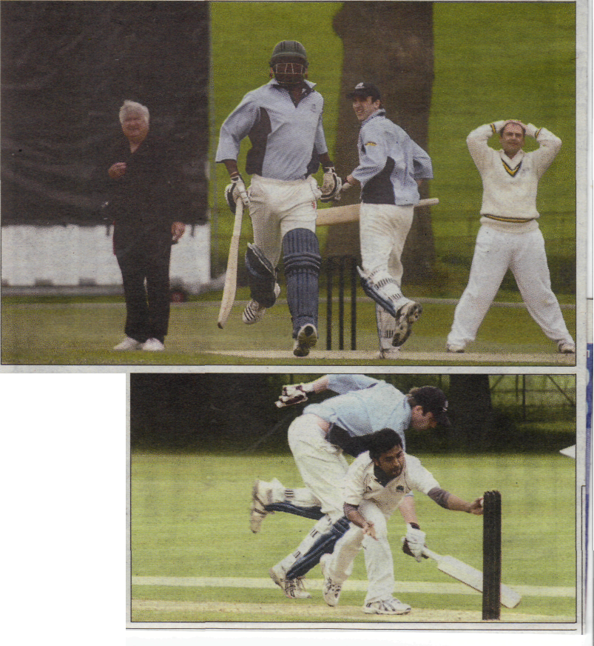
• ACTION: Above, Chesham bowler Hitesh Mody rues a missed chance as Harefield rack up the runs
BU250509sdtwent01
• ACTION: Right, bowler Yohan Peries fails in a runout attempt
BU250509sdtwent09
(by Tim Edwards timpedwards@trini1ysouth.co.uk
THE inaugural Amersham Cricket Club Twenty2O Tournament on bank holiday Monday saw the Harefield Hawks reign supreme.
They swept past the host club and Chesham in the three-way event at Shardeloes that saw a mix of experienced campaigners and thriving talent take to the field.
And it captured the imagination of the winners so much so they have decided to stage their own Twenty20 competition featuring the same sides, who all play in the Morrant Thames Valley League Division One, on the next bank holiday, August 31.
The Hawks posted 177 for six against Chesham with Richard McLeod (30) and Jack Shiel (40) leading the way with the bat.
Chesham could only muster up 170 for eight in their 20 overs with Doug King taking four wickets.
Akshay Heddy (80) provided the bulk of Harefield's 179 for eight in the next match with Amersham, while Mluleki Nkala showed his class by hitting three sixes and two fours in one over.
In reply Amersham fell short at 173 for nine to hand the Hawks the title. • More pictures from the tournament online at www.buckinghamshireexaminer.co.uk

