Amersham remain on top after Chesham stalemate
DERBY: Team held by local rivals despite solid start

CRICKET
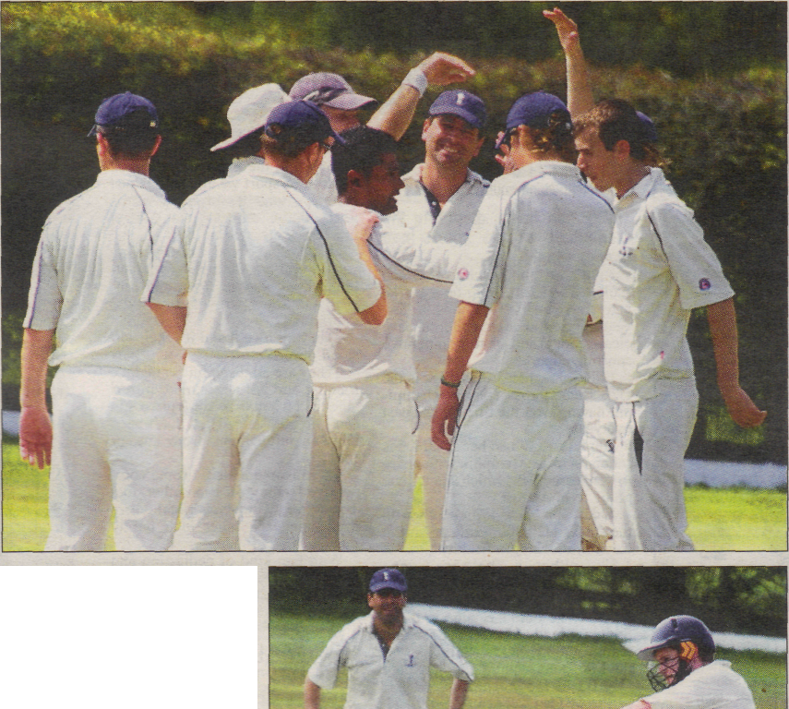
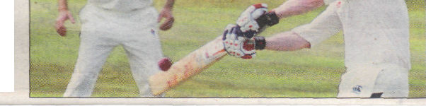
• WELL DONE: (above) Chesham celebrate a wicket, and (right) an Amersham batsman at the crease
Pictures by Jon Smalldon
top spot on 127 points. Harefield beat Tring Park while Thatcham overcame Maidenhead and Bray to share the lead.
Kew sit five points behind and fifth-placed North Maidenhead are 26 points further adrift.
by Yarn Tear
yanntear@trinitysouth.co.uk
AMERSHAM had much the better of a draw with Chesham at Shardeloes on Saturday after posting an imposing total of 273-3 off 52 overs.
They looked odds-on to claim victory when Chesham's former Sri Lanka A batsman Bradman Ediriweera - one of the shining lights in the Thames Valley league - was dismissed for one run.
But the determined and skilful Rob Maier stepped up to the plate with a stubborn knock of 70 to deny Amersham victory.
The game had got off to a careful start as tight bowling from Adris Ahmed, Tom Helm and Ediriweera prevented the rapid accumulation of runs.
However, Chris Fleming (112), Chris Cann (64) and skipper Luke Jackson (73 not out from 36 balls) kept the Scoreboard moving. Jackson blasted six sixes, including four in one over off Martin Wheeler, and six fours.
Ediriweera was out in the second over, miscuing Cann into the hands of Andy Viney at cover.
But Maier had other ideas and his innings did much to curb Amersham's hopes of a win.
His departure, followed by that of Peter Clifford four runs later, came too late to alter the course of the match, especially as a break of 45 minutes soon followed to allow a slow-moving thunderstorm to trundle out of range. They closed on 167-7 from 48 overs.
The result leaves Amersham joint top of the league. Three clubs share

